

Indian Institute of Technology

Rupnagar, 140001, India

Tinkering Lab Report

on

Accident Alert System

Submitted by

Chanchal Rai 2017med1005

Angadeep Singh 2017med1003

Tarun Verma 2017med1010

Praveen Sheharia 2017ceb1024

Shyam meherwal 2017ceb1030

Supervised by

Dr. Chandi Sasmal

in

Fourth semester

# Introduction

In this project, we are going to build an **Arduino based vehicle accident alert system using GPS, GSM and accelerometer**. Accelerometer detects the sudden change in the axes of vehicle and GSM module sends the alert message on your Mobile Phone with the location of the accident. Location of accident is sent in the form of Google Map link, derived from the latitude and longitude from GPS module. This Vehicle Accident alert project can also be used as a Tracking System and much more, by just making few changes in hardware and software.

# Motivation behind the Project

Our motivation behind it is the alarming number of accidents that take in India daily. Over 1,37,000 people were killed in road accidents in 2013 alone, that is more than the number of people killed in all our wars put together. One serious road accident in the country occurs every minute and 16 die on Indian roads every hour. 1214 road crashes occur every day in India. Two wheelers account for 25% of total road crash deaths.20 children under the age of 14 die every day due to road crashes in in the country. 377 people die every day, equivalent to a jumbo jet crashing every day. Two people die every hour in Uttar Pradesh – State with maximum number of road crash deaths. Tamil Nadu is the state with the maximum number of road crash injuries.

With the help of a device like the one which we have made, the number of casualties due to such accidents can be significantly decreased. Most of the deaths happen because of delay in treatment. With an instant accident beacon help can reach much faster and many lives can be saved.

# COMPONENTS REQUIRED:

* Arduino Uno
* GSM Module (SIM900A)
* GPS Module (SIM28ML)
* Accelerometer (ADXL335)
* 16x2 LCD
* Power Supply
* Connecting Wires
* 10 K-POT
* Breadboard or PCB
* Power supply 12v 1amp

## GPS MODULE:

GPS stands for Global Positioning System and used to detect the Latitude and Longitude of any location on the Earth, with exact UTC time (Universal Time Coordinated). GPS module is used to track the location of accident in our project. This device receives the coordinates from the satellite for each and every second, with time and date.

**GPS module** sends the data related to tracking position in real time, and it sends so many data in NMEA format. NMEA format consists several sentences, in which we only need one sentence. This sentence starts from **$GPGGA** and contains the coordinates, time and other useful information. This **GPGGA** is referred to **Global Positioning System Fix Data**.

## GSM MODULE:

The SIM900 is a complete Quad-band GSM/GPRS Module which can be embedded easily used by customer or hobbyist. SIM900 GSM Module provides an industry-standard interface. SIM900 delivers GSM/GPRS 850/900/1800/1900MHz performance for voice, SMS, Data with low power consumption. SIM900 designed by using single-chip processor integrating AMR926EJ-S Core Quad - band GSM/GPRS module in small size.

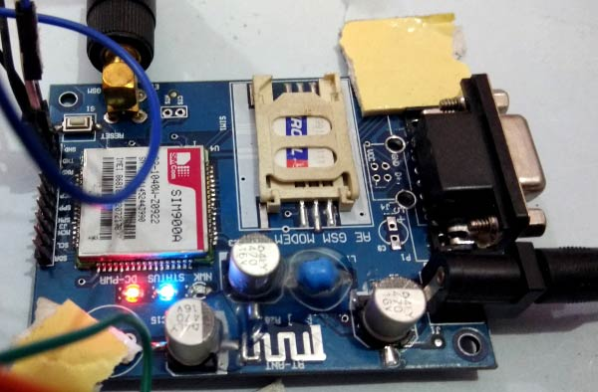

## ACCELEROMETER:

Pin Description of accelerometer:

* Vcc         5-volt supply should connect at this pin.
* X-OUT   This pin gives an Analog output in x direction
* Y-OUT   This pin gives an Analog Output in y direction
* Z-OUT   This pin gives an Analog Output in z direction
* GND      Ground
* ST          This pin used for set sensitivity of sensor

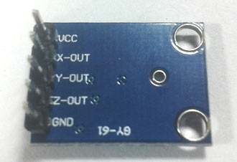

## ARDUINO UNO:

The board is equipped with sets of digital and analog input/output (I/O) pins that may be interfaced to various expansion boards (shields) and other circuits. The board has 14 Digital pins, 6 Analog pins, and programmable with the Arduino IDE (Integrated Development Environment) via a type B USB cable. It can be powered by a USB cable or by an external 9-volt battery, though it accepts voltages between 7 and 20 volts.

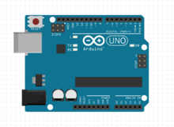

# Working

In this project we have built an Arduino based vehicle accident alert system. Whenever there is a sudden change in axis of the vehicle accelerometer detects it and sends the location derived in the form of latitude and longitude to the mobile phone in the form of a google map link.

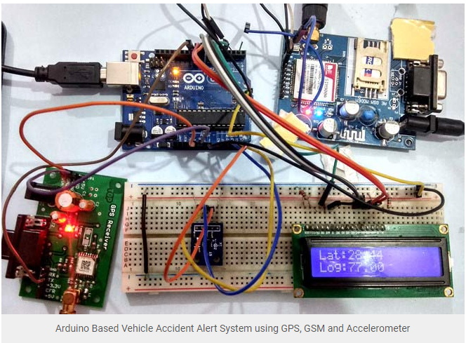

Global positioning system (GPS) is used to calculate the latitude and longitude of any location on the earth with exact Universal time coordinate(UTC). The device receives coordinates from the satellites for each and every second, with time and date. GPS module sends the data in the real time in the NMEA format which contains several sentences out of which we need only one sentence starting with the string $GPGGA we can get the location from the $GPGGA by counting the number of commas in the string, latitude is the value after the 2nd comma and the longitude is the value after the 4th comma. Further these are stored in a separate array to display it on the LCD screen.

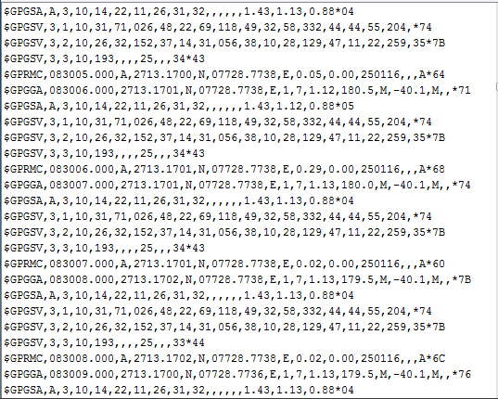

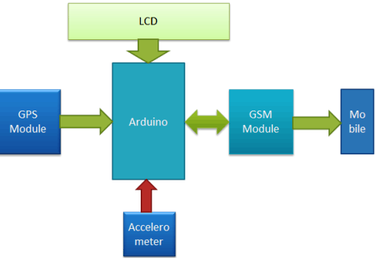

Once we are ready with our hardware after programming we can install the device in our vehicle and power it up. Now whenever there is an accident there is a tilt in the vehicle which changes the axis value. These value are read by Arduino and it checks if any change occur in any axis. If any change occurs, then Arduino reads coordinates by extracting the $GPGGA string from the GPS module and sends an accident alert message on the predefined number in the code. The message contains the Latitude, Longitude and the google map link of the location of the victim.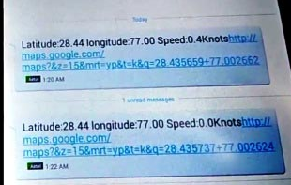

## Benefits of the accident alert system

In India, there are a lot of road accidents. The below figure shows the number of road accidents in the year 1970 to 2015.

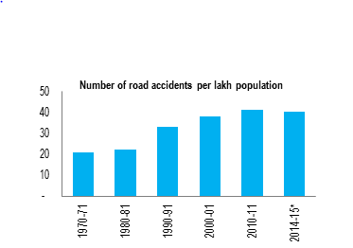

Our device can reduce the count of the people dying in these road accidents as many times what happens is that the assistance is not able to reach the victim which leads to the death of many people whose life can be saves by sending the assistance at the right time.

# Future Modification

* Present time location

It works like if someone send message to the sim attached to the GSM Module, then he will get the link of the person’s location at that time and speed of the vehicle. Message to be sent is to be very confidential so that no one else can track your child. This can be very beneficial for the parents guarding their children.